**C1 Horse Management Checklist 2023**

Candidates: Each box in ***Section 1*** must be signed off by your instructor.

Topics in ***Section 2*** must be filled out like a study guide and turned in

with Section 1, four weeks prior to test date.

**Section 1:**

|  |  |
| --- | --- |
| Topic | Sign & Date |
| Candidate’s mount and tack to reflect the Horse Management Handbook’s Turnout expectations. |  |
| Mount to be well-groomed, reflecting regular care with a healthy coat; no sweat or dirt. Mane and tail brushed with little, if any, dandruff. External areas around sheath/udder clean. Eyes, nose, lips, and dock clean. |  |
| Tack to be safe, clean, and properly adjusted, reflecting regular care/conditioning with metal polished. No jockeys or dust and all stress points clean. |  |
| Present in appropriate “competition” attire for either dressage, eventing, or show jumping discipline (found in the respective discipline rulebooks) |  |
| Demonstrate parallel leading, from both sides, at the walk only, with assistance if necessary, as described in the USPC C Manual. |  |
| Apply 2 stable (aka standing) bandages (front and rear diagonal pair) with assistance from examiner if needed. |  |
| Bring a letter from the DC verifying member assisted twice at an unmounted pony club activity. |  |
| Provide a hard copy (in a folder/binder) of mount’s Health and Maintenance Record Book that contains records for at least 6 months prior to the test. In addition to the information from the previous levels (D2/D3), records must contain:  D2   * Horse information and photo * Contact info for vet and farrier * Feeding info and schedule   D3   * Dated list of routine care (vaccinations, deworming, shoeing, dentistry) * Daily schedule of care which may include grooming, riding, clinics, etc.   C1   * Weekly riding/conditioning schedule and changes to this schedule (seasonal or other) * Activities (beyond daily routine, eg lessons, clinics, competitions, etc) * Extra vet visits (beyond routine care) * Expenses (income may be added, but not required) |  |
| Demonstrate a safety and tack inspection for a D member (explaining any safety issues found) to include:   * Rider attire (helmet, boots, medical armband) * Bit is right way up and is attached to bridle correctly * Curb chain adjusted correctly if using * Crownpiece/headstall and browband fitted * Reins attached correctly * Billets, stirrup leathers, and reins in good repair * Girth is good size for moutn and in good condition * Saddle fits moutn and rider and pad is correctly attached. * Pony’s feet picked out. |  |

**Section 2:**

**Presentation/Turnout/Tack**

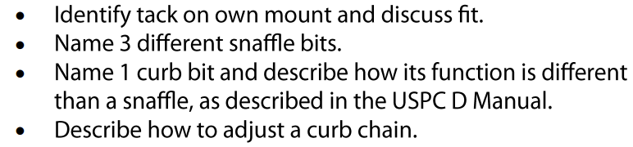

**Leading/Longing**

**Bandaging**



**Foot and Shoeing**

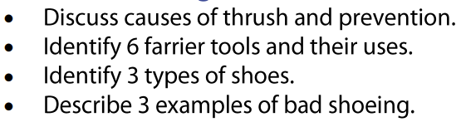

**4**

**Conformation and Unsoundness**

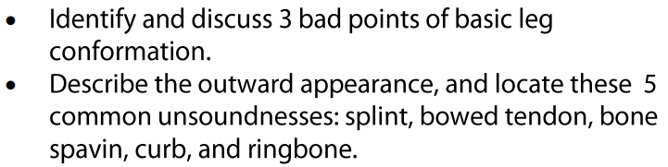

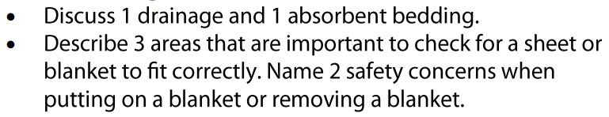**Stable Management**

**Stable Management, cont.**



**Travel Safety**

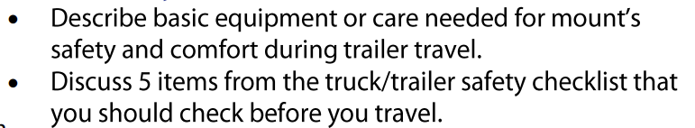

**Nutrition**

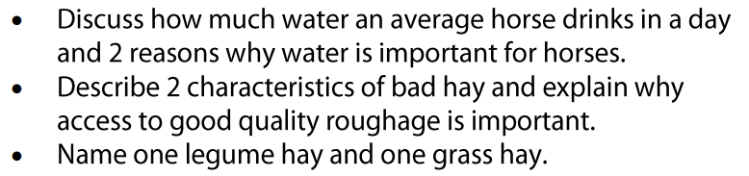

**Condtioning**

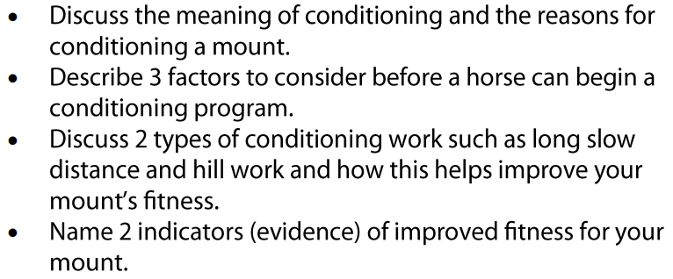

**Land Conservation**

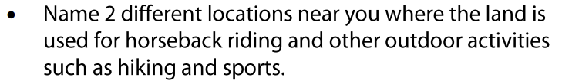

**Rider Safety**

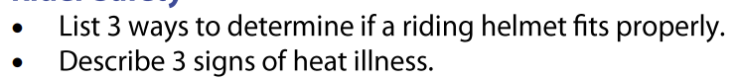

**Health Care and Veterinary Knowledge**

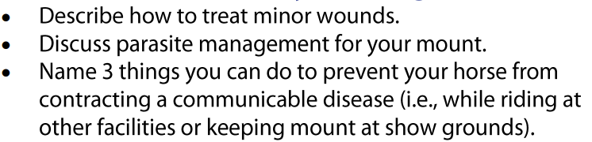

**Health Care and Veterinary Knowledge, cont.**

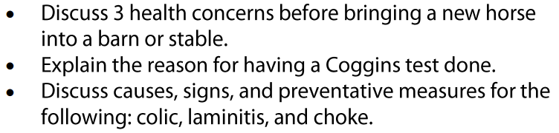

**DC Signature _______________________________________________________________**

**Date Received_______________________________________________________________**